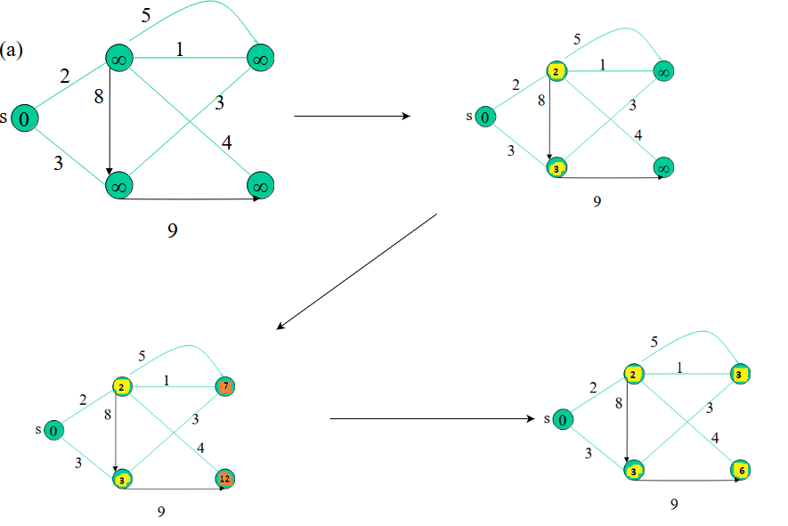
The step-by-step solution for Bellman-Ford algorithm.

